**Cryptoverse: A Cryptocurrency Dashboard**

**Ideation Phase**

**Define the Problem Statements**

|  |  |
| --- | --- |
| Date | 10/03/2025 |
| Team ID | SWTID1741515377152564 |
| Project Name | Cryptocurrency dashboard |
| Maximum Marks | 2 Marks |

**Customer Problem Statement Template:**

Create a problem statement to understand your customer's point of view. The Customer Problem Statement template helps you focus on what matters to create experiences people will love.

A well-articulated customer problem statement allows you and your team to find the ideal solution for the challenges your customers face. Throughout the process, you’ll also be able to empathize with your customers, which helps you better understand how they perceive your product or service.

Reference: <https://miro.com/templates/customer-problem-statement/>

**Example:**

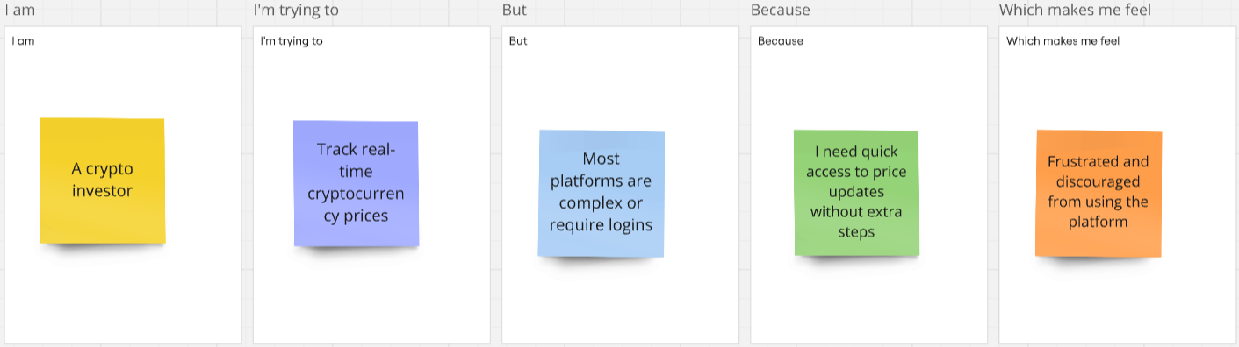

|  |  |  |  |  |  |
| --- | --- | --- | --- | --- | --- |
| Problem Statement (PS) | I am (Customer) | I’m trying to | But | Because | Which makes me feel |
| PS-1 | A crypto investor | Track real-time cryptocurrency prices | Most platforms are complex or require logins | I need quick access to price updates without extra steps | Frustrated and discouraged from using the platform |
| PS-2 | A beginner in crypto | Understand market trends easily | The available dashboards are too technical | I need a simple, visually appealing interface to analyze data | Overwhelmed and unsure about making decisions |
| PS-3 | A day trader | Monitor price fluctuations and make quick decisions | The API data is slow or not updating in real-time | I need instant updates to react to market changes quickly | Anxious and unable to trade efficiently |
| PS-4 | A user tracking multiple coins | Compare different cryptocurrencies in one place | Most platforms focus on a few major coins | I want a customizable dashboard that lets me track my preferred assets | Limited and forced to use multiple apps |